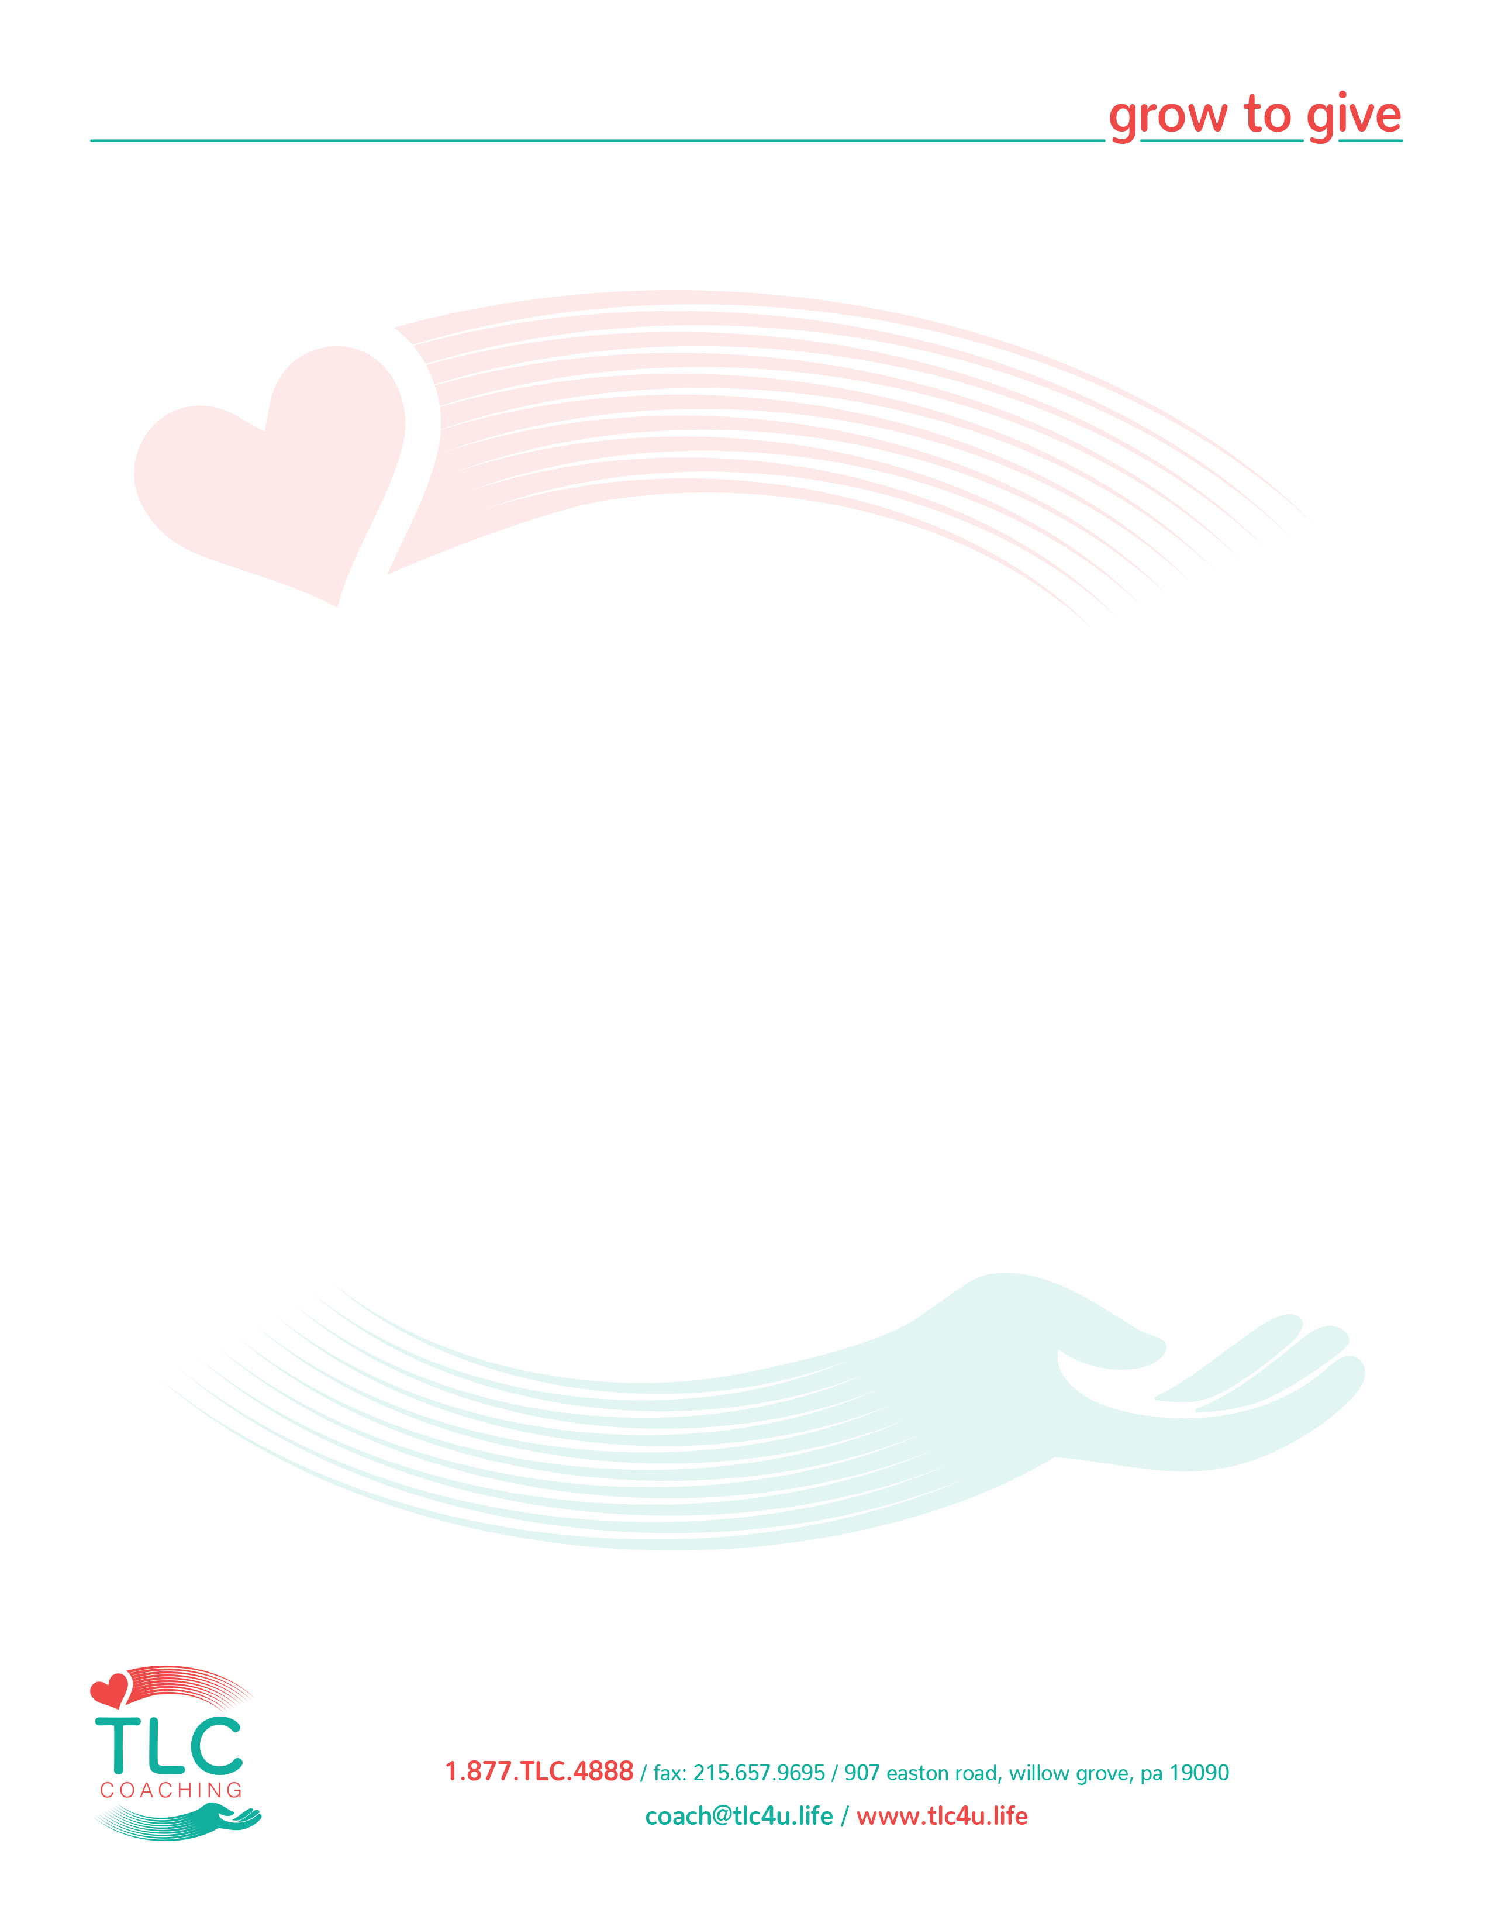
DC Foundation Coaching – Phase 1 – Homework Assignment

Get the most from your TLC coaching. ENGAGE with TLC and you will receive richly. Every second that you invest in conference calls, training on new procedures and opening your heart to learn more will be fruitful. We want prosperity for you in every area of your life. Let us make this beginning with TLC SIMPLE. The program works. Let us come alongside you and you will see that this program is in a league of its own. TLC is true coaching and community that cares about you growing.

Title: Gratitude, Joy and Simplicity

Disciplines: G.A.S.
Magic of 1

- E-Sign Membership Agreement – this was emailed to you.

- G.A.S. (Gratitude, Action, and Service):
- Watch video entitled “Foundation Discipline – G.A.S.” posted in Phase 1
- Each day write on one side of an index card your 3 to 7 gratitude’s, 3 to 7 actions and 1 selfless service you plan to do. Carry the card with you all day.
- First thing in the morning every day, text a picture of your index card to your Foundation group with WhatsApp on your smart phone.

WhatsApp Information:
- If You Have WhatsApp Already
  - Follow the link we texted you leading you to your unique TLC WhatsApp Foundation group.
- If You Have Not Yet Downloaded WhatsApp –
  - Follow the link we texted you leading you to your unique TLC WhatsApp group.
  - It will prompt you to download "WhatsApp."
  - Once you have downloaded it, you can follow the link we texted you again and you will automatically see your Foundation Group pop up on your WhatsApp display.
- Magic of 1:
- Watch video entitled: “Foundation Discipline – Magic of 1” posted in Phase 1.
- BEGIN to speak and write your Statement of Desire and complete this section on your Magic of 1 Triangle on the TLC website at Member Tools, Interact, Magic of 1, Submit Your Magic of 1

Additional Engagement this week: Review Foundation Member Timeline on website.

Assignment: Please complete by the day before your LIVE Foundation call.
Questions: Contact us at 1-877-852-4888

KEEP IT SIMPLE, FOLLOW THE STEPS AND BREATHE

