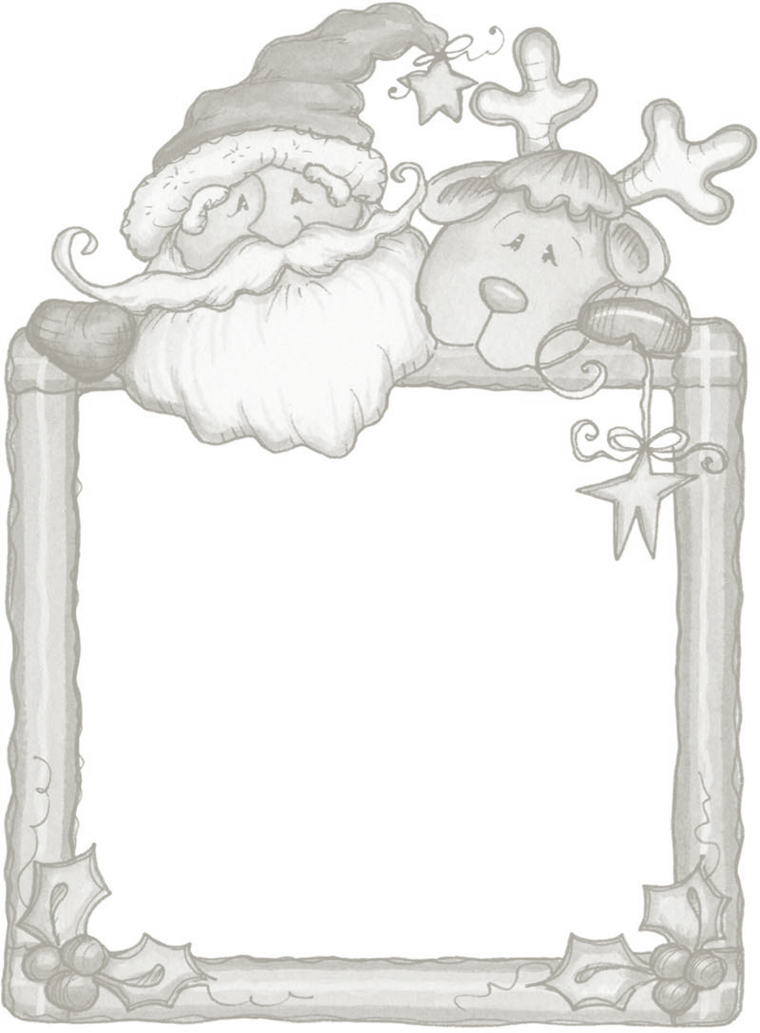
CC MADLIB:
The object of the game is to create something that sounds funny and silly! Don’t read the story first! Fill in the word then read the story with the words you chose! Give it to a CC team member when you are done to be entered to win a $75.00 Visa Gift Card!

- ADJECTIVE__________________
- ADJECTIVE__________________
- VERB__________________
- NOUN__________________
- ADJECTIVE__________________
- TIME PERIOD__________________
- ADJECTIVE__________________
- ADJECTIVE(feeling) __________________
- ADJECTIVE__________________
- ADJECTIVE__________________
- ADJECTIVE__________________
- ADJECTIVE-Feeling__________________
- ADJECTIVE__________________
- ADJECTIVE__________________
- ADJECTIVE__________________

The First CA Workshop!
It was the night of the 1.______________ spinal workshop, The inside Scoop, that the 2.___________________ chiropractic assistants Katrice and Rebecca were hosting. The day before, Rebecca had 3. _______________ the spinal workshop calls and reminded everyone of their 4. _________________ for the workshop. She was very 5. _________________ as this was her and Katrice’s first spinal workshop that they had ever done. They had spent 6.______________ preparing the talk and what exactly they wanted to discuss with their 7.______________ patients. As the day approached five o’clock Katrice and Rebecca both began to feel very 8.________________. They arranged the chairs in 9. _________________ rows as they were expecting about 10 patients at the workshop. One of the attendees was their new 10. _______________ assistant, Dianne whose 11. _______________ personality added a whole new dynamic to the office. As the patients arrived, they were greeted with snacks and water, which made Dr. Jason feel very 12.__________________ as he does not have these at his workshops. The workshop went 13._______________ and everyone was very happy that they attended. Even Dr. Jason said that this workshop was 14. ________________ than his! After all of their time and preparation Katrice and Rebecca were very 15._________________ with their success of their workshop and cannot wait to plan their next one!

