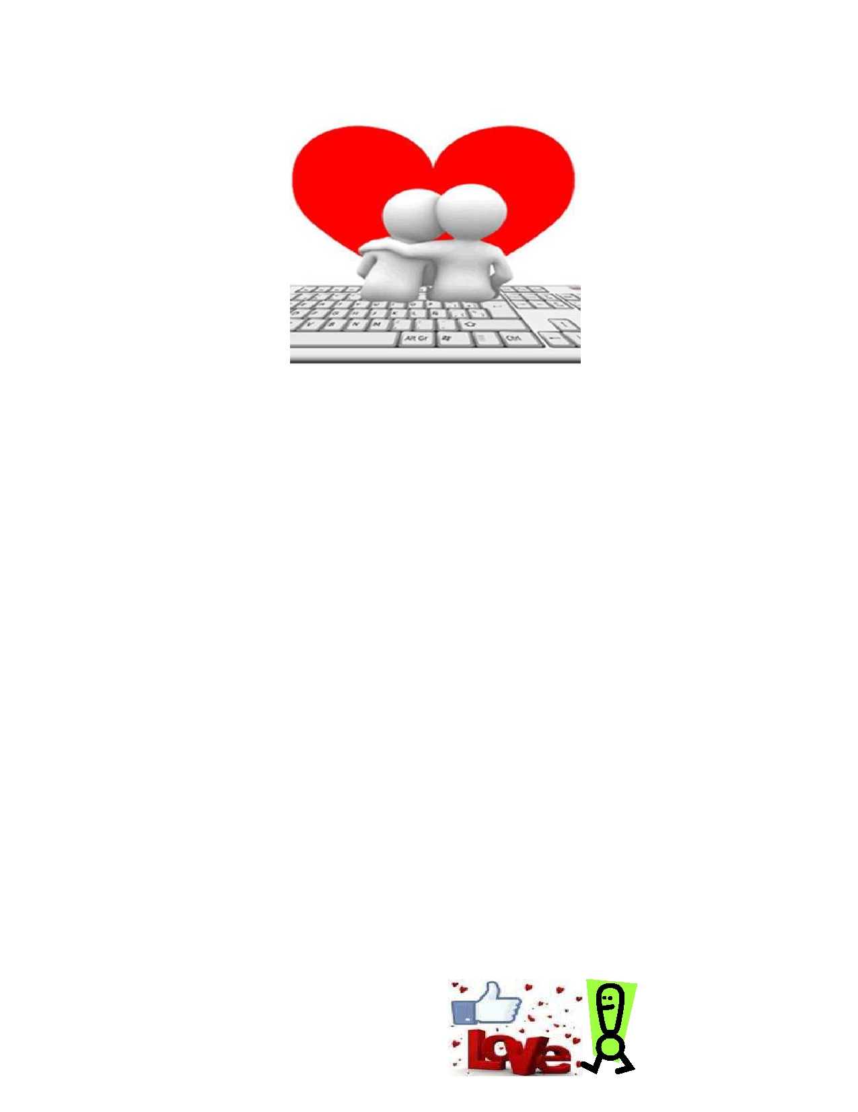
SHARE THE LOVE CONTEST

Starting today, Acton Chiropractic is launching the SHARE THE LOVE Contest.

All you have to do to enter is tell us why you

LOVE

Acton Family Chiropractic!

The grand prize winner will receive a $100 Gas gift card!

Each entry must include:
A story from your heart about Acton Family Chiropractic's office.
Why you LOVE coming to our office and what you LOVE about chiropractic in general.

You can enter in the following ways:

Write a short review on Google, yahoo and yellow pages.com.
If you need help ask the front desk and we will give you instructions.

Post to Facebook on Acton Family Chiropractic's wall.
Three winners will be drawn at the beginning of July.

You'll receive one entry for each category you post on.

The grand prize winner will receive a $100.00 Gas gift card.
Two runners up will receive a $25.00 gas gift card.
And the patient with the most "likes" on their story will receive a $50 gas gift card.

Now go out there and show some

